Software Development Unit 33, 3.4

Anna Legaspi

# I can explain the effectiveness of tests and reflect on their purpose

In Software Development Unit 33, 1.4, we’ve discussed the different types of testing and briefly touched upon the benefits of testing as well. In this unit, I will describe how each type of testing can be effective and ineffective. I will also go through the purpose of testing in further detail.

## Purpose of Testing

Testing is important as this is a thorough way of checking that the requirements (user cases, business rules) is applied to the working software. It is possible to have a partially working software that appears to function as intended, but if tested in a variety of scenarios, it actually has defects that needs to be investigated and resolved. It is also possible that the software works in one environment, but not another (ST versus UT, etc).

Overall, it is the Tester’s responsibility to create a test that takes into consideration the user experience, user story requirements and business rules. They conduct the tests and raise any defects they find to the developers. The devs work on these defects to create a more robust, functioning software that is fit for purpose and harder to ‘break’. If the software delivered ticks all the boxes, then customer satisfaction is also guaranteed.

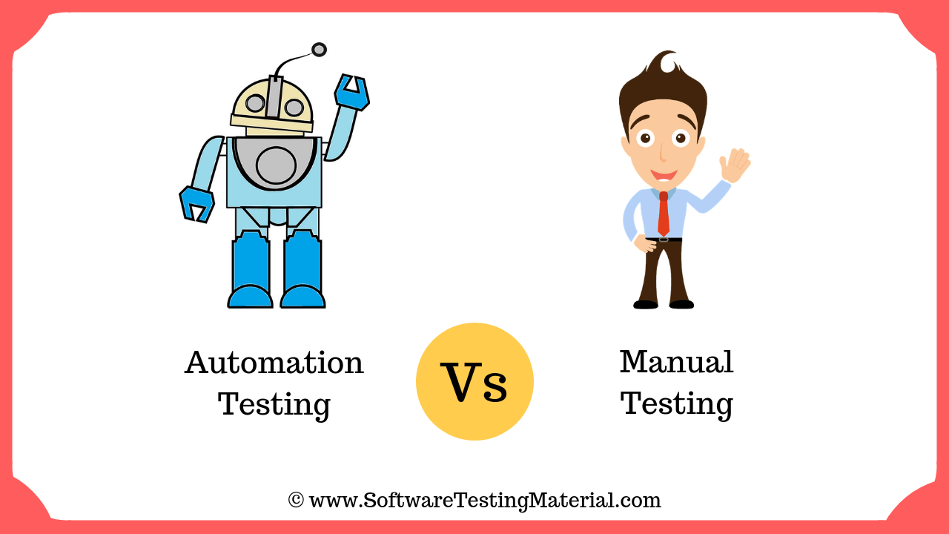

## Manual testing

Manual testing is relying on a User Tester to manually test the software without the use of automated testing software. This means creating a spreadsheet which captures what needs testing (requirements) and the tester pretending to be the user and test that it works. The benefits and effectiveness of this type of test is that humans have the ability to see the ‘bigger picture’. Complex scenarios aren’t always picked by automated testing, but humans can pick this up. On the other hand, because the test is conducted by humans, there is also room for error and for testers.

**Team Project Testing**

In our website project for Unit 33, 2.1-2.5, we’ve tested our website manually as ‘users’ even though we all have some knowledge of HTML and CSS and have used these skills to create our webpages. We conducted our testing this way for several reasons. Firstly, the creators of their own webpage would be the only one who knows if the content is correct, however, not everyone had knowledge of the HTML and CSS of the overall website. It made sense for each team member to test their own webpage once it was integrated into the main website. Secondly, since we were testing a small website, it didn’t take too long to complete a high-level test with not much requirements since it was the first sprint. Thirdly, none of us had knowledge of automation testing.

Testing our website made it possible for us to realise the existing defects within our main website. It made us realise that the font was an issue in other browsers, that the CSS wasn’t working in all of the webpages and that some navigation links weren’t working as intended. Detecting this defects means we can improve on it, fix it and improve our software.

## Automation testing

Automation testing requires skills from automation developers and to have a tool that can test the software. It has a few benefits and disadvantages in comparison to manual testing. For example, automation testing can be run at any time with less cost since it doesn’t need a team of manual testers available. It can also test simple, monotonous and repetitive tasks that humans may miss. Saying that, the more complex the journey is within the software, automation testing may not be the most appropriate.

## V model testing

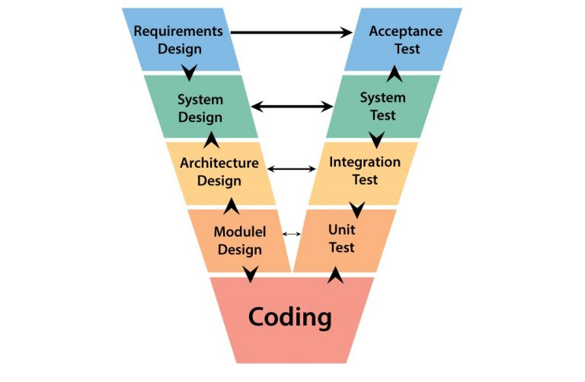

The V model testing is more of when the testing takes place instead of how the testing is done. With the V model, testing is conducted at every stage of the product development cycle, which means that bugs are identified early in the project. This can be beneficial potential issues are avoided even before a prototype product is even created. On the other hand, it is very likely to encounter problems in software development. If a massive issue is detected halfway through the V model testing process, the requirements and testing documents will need to be re-assessed and updated.